**Geography**

We will be learning about The Water Cycle and Rivers. We will look at the effects of the water cycle on British cities, some of the main features of a river focusing on the UK and Europe.

**PSHE**

Our PSHE theme is ‘Living in the Wider World’. We will be exploring media literacy and digital resilience. Here we learn how everything shared online has a digital footprint and that organisations can use personal information to encourage people to buy things

**English**

The children will be learning to write letters using the book ‘Escape from Pompeii’ By Christina Balit. Linking in with Religion, we will be writing a recount using the Easter Story as our starting point. Our grammar focus will be pronouns and possessive apostrophes, adverbs and adverbial phrases.

Spellings will be given weekly, with a spelling test on Tuesdays. Children will be given daily opportunities to practice their handwriting, focusing on the diagonal and horizontal strokes that are needed to join letters and understand which letters are best left un-joined.   
Our Class text will be ‘How to Train Your Dragon’ By Cressida Cowell.

Reading books should be brought in every day. Please spend time reading with your child each evening and record this in your child’s reading record.

**Religion**

Year 4 will be studying the topic ‘Jesus, the Saviour’. Children will know that Jesus is truly God and truly human. We will learn about Jesus’ entry into Jerusalem and understand what happened on Holy Week and why Jesus died on the cross.

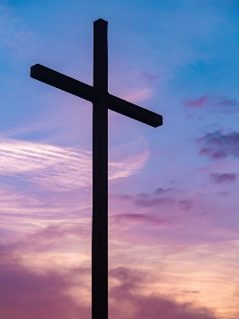

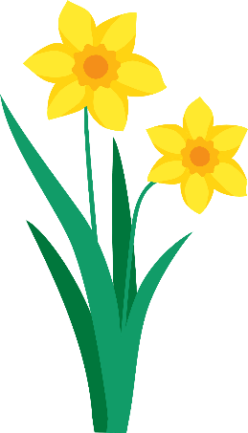

Year 4  
Spring 2  
Miss Bowen and

Miss Meehan

Spring 2

**Computing**

Writing for Different Audiences.  
In this unit, children will learn that technology can be used to organise, develop and explore ideas. We will explore font styles, produce a news report and write for a campaign.

**Science**

In Spring 2, we will continue with our topic of Sound. We will then move on to learning about Electricity. Here we will identify common appliances that run on electricity and construct a simple series electrical circuit, identifying and naming its basic parts, including cells, wires, bulbs, switches and buzzers.



**Art**

We will be completing our topic of ‘Fabric and Nature’. Using the flora and fauna of tropical rainforests as a starting point, children develop drawings through experimentation and textile-based techniques to design a repeating pattern suitable for fabric.

**Music**

We will be working from the Kapow music scheme. The children will be linking their learning in music to our geography topic. They will represent different stages of a river through vocal and percussive ostinatos, culminating in a final group performance.

**PE**

The children will continue to have 2 hours of PE each week. On Monday, the children will be learning Dance and on Thursdays, we will begin swimming. Swimming will continue until the end of the year. Please remember to bring a swimming kit on Thursday and come in in PE kit on Mondays.

**Maths**

In Spring 2, we will learn about Length and Perimeter. We will be focusing on rectangles and rectilinear shapes and polygons.  
We will then move on to fractions, finding the links between tenths and hundredths, equivalent fractions and simplifying fractions.   
The children will then be introduced to decimals, the decimal point and the tenth and hundredth columns. The children will learn to order and round decimals.

**By then end of year 4 children will need to know all their times tables to 12 x 12. We will practice these in school and it would be really beneficial if parents can reinforce this learning at home too.**

**French**

The children will continue to learn to converse in French. They will learn to talk about games and sing songs.