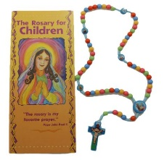**Prayers for the Rosary**

**Our Father x1**

Our Father, Who art in heaven, hallowed by Thy name; Thy kingdom come; Thy will be done on earth, as it is in heaven. Give us this day our daily bread; and forgive us our trespasses, as we forgive those who trespass against us; and lead us not into temptation, but deliver us from evil. Amen.

**Hail Mary x10**

Hail Mary, full of grace, the Lord is with thee, blessed art thou among women, and blessed is the fruit of thy womb Jesus. Holy Mary, Mother of God, pray for us sinners now, and at the hour of our death. Amen.

**Glory Be to the Father x1**

Glory be to the Father, and to the Son, and to the Holy Spirit. As it was in the beginning, is now, and ever shall be, world without end. Amen.

**Our Father x1**

Our Father, Who art in heaven, hallowed by Thy name; Thy kingdom come; Thy will be done on earth, as it is in heaven. Give us this day our daily bread; and forgive us our trespasses, as we forgive those who trespass against us; and lead us not into temptation, but deliver us from evil. Amen.

**Hail Mary x10**

Hail Mary, full of grace, the Lord is with thee, blessed art thou among women, and blessed is the fruit of thy womb Jesus. Holy Mary, Mother of God, pray for us sinners now, and at the hour of our death. Amen.

**Glory Be to the Father x1**

Glory be to the Father, and to the Son, and to the Holy Spirit. As it was in the beginning, is now, and ever shall be, world without end. Amen.